**Sample Written examination # 5 – By Jack Graffeo**

**November 2023**

**Reading time: 15 mins**

**Writing time: 2 hours**

**QUESTION AND ANSWER BOOK**

**Structure of the exam**

|  |  |  |  |  |  |
| --- | --- | --- | --- | --- | --- |
|  | *Section* | *Number of questions* | *Number of questions to be answered* | *Number of marks* |  |
|  | A | 10 | 10 | 60 |  |
|  | B | 4 | 1 | 20 |  |
|  |  |  |  | Total 80 |  |

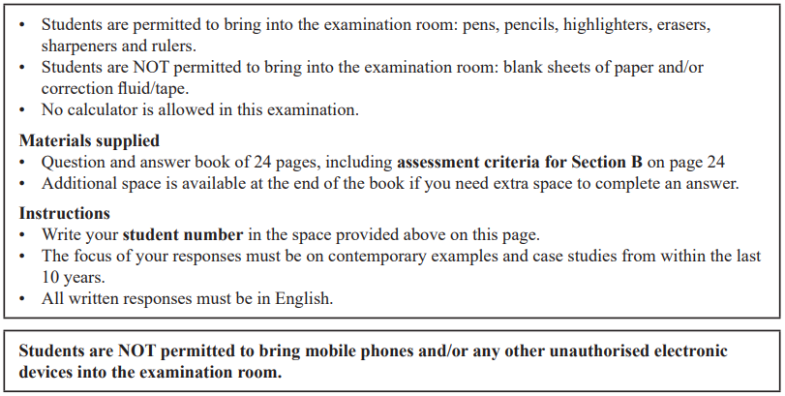

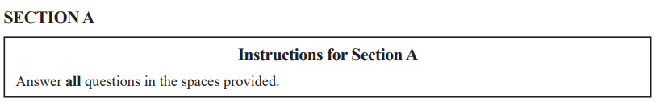

**Question 1** (4 marks)

1. Identify one aim of a Transnational corporation (TNC) in global politics. (1 mark)

|  |
| --- |
|  |
|  |
|  |

1. Explain one limitation to the ability of this TNC to achieve this aim. (3 marks)

|  |
| --- |
|  |
|  |
|  |
|  |
|  |
|  |
|  |
|  |
|  |

**Question 2** (4 marks)

Explain how one terrorist non-state actor has challenged the sovereignty of a state.

|  |
| --- |
|  |
|  |
|  |
|  |
|  |
|  |
|  |
|  |
|  |
|  |
|  |
|  |

**Question 3** (7 marks)

Compare and contrast the power of two Intergovernmental Organisations (IGOs) in global politics.

|  |
| --- |
|  |
|  |
|  |
|  |
|  |
|  |
|  |
|  |
|  |
|  |
|  |
|  |
|  |
|  |
|  |
|  |
|  |
|  |
|  |
|  |
|  |

**Question 4 (15 marks)**

One of the following Asia-Pacific states must be used as the focus of all responses to Question 4: Australia, China, Indonesia, Japan or the United States of America.

Selected Asia-Pacific state: ____________________________________________________

1. Describe the diplomatic power held by this Asia-Pacific state. (2 marks)

|  |
| --- |
|  |
|  |
|  |
|  |
|  |
|  |

1. Evaluate the effectiveness of this Asia-Pacific state’s use of soft power to pursue regional relationships. (5 marks)

|  |
| --- |
|  |
|  |
|  |
|  |
|  |
|  |
|  |
|  |
|  |
|  |
|  |
|  |
|  |
|  |
|  |

1. Analyse the influence of idealism and pragmatism on this Asia-Pacific state’s pursuit of national security. (8 marks)

|  |
| --- |
|  |
|  |
|  |
|  |
|  |
|  |
|  |
|  |
|  |
|  |
|  |
|  |
|  |
|  |
|  |
|  |
|  |
|  |
|  |
|  |
|  |
|  |
|  |
|  |

**Question 5** (3 marks)

Using an example, explain the term ‘realism’ as it relates to the study of global politics.

|  |
| --- |
|  |
|  |
|  |
|  |
|  |
|  |
|  |
|  |
|  |

**Question 6** (6 marks)

From the list below, select one ethical issue that you have studied this year:

• human rights

• people movement

• development

• arms control

Ethical issue: _______________________________________________________________

Analyse the success of one international law in supporting the resolution of this ethical issue.

|  |
| --- |
|  |
|  |
|  |
|  |
|  |
|  |
|  |
|  |
|  |
|  |
|  |
|  |
|  |
|  |
|  |
|  |
|  |
|  |

**Question 7** (6 marks)

Select another ethical issue that you have studied this year. The ethical issue selected must be **different** from the one selected in Question 6.

Ethical issue ________________________________________________________________

Discuss how a global actor’s perspective may determine their view on how justice can be achieved in relation to this ethical issue.

|  |
| --- |
|  |
|  |
|  |
|  |
|  |
|  |
|  |
|  |
|  |
|  |
|  |
|  |
|  |
|  |
|  |
|  |
|  |
|  |

**Question 8** (2 marks)

From the list below, select one global crisis that you have studied this year:

**You must respond to the same global crisis in Question 8 and 9.**

• climate change

• armed conflict

• terrorism

• economic instability

Global crisis: _______________________________________________________________

Describe one key aspect related to this global crisis.

|  |
| --- |
|  |
|  |
|  |
|  |
|  |
|  |

**Question 9** (5 marks)

Analyse how globalisation has exacerbated this global crisis.

**You must respond to the same global crisis as Question 8.**

|  |
| --- |
|  |
|  |
|  |
|  |
|  |
|  |
|  |
|  |
|  |
|  |
|  |
|  |
|  |
|  |
|  |

**Question 10** (8 marks)

Select another global crisis that you have studied this year. The global crisis selected must be **different** from the one selected in Question 8 and 9.

Global crisis ________________________________________________________________

Assess the extent to which responses from global actors have addressed the causes of this global crisis.

|  |
| --- |
|  |
|  |
|  |
|  |
|  |
|  |
|  |
|  |
|  |
|  |
|  |
|  |
|  |
|  |
|  |
|  |
|  |
|  |
|  |
|  |
|  |
|  |
|  |

**SECTION B**

Write an essay on one of the following questions in the space provided.

Your response will be assessed according to the assessment criteria set out on the back page.

**Question 1** (20 marks)

‘Transnational corporations present the most significant challenge to the power of the state.’ To what extent do you agree?

**OR**

**Question 2** (20 marks)

Don’t do this question, unless you want to do bad on this exam.

**OR**

**Question 3** (20 marks)

‘States have an obligation to pursue cosmopolitanism in regards to ethical issues.’ Discuss with reference to at least one ethical issue.

**OR**

**Question 4** (20 marks)

Evaluate the effectiveness of the responses from global actors to one global crisis that you have studied this year.



|  |
| --- |
|  |
|  |
|  |
|  |
|  |
|  |
|  |
|  |
|  |
|  |
|  |
|  |
|  |
|  |
|  |
|  |
|  |
|  |
|  |
|  |
|  |
|  |
|  |
|  |
|  |
|  |
|  |
|  |
|  |
|  |
|  |
|  |
|  |
|  |
|  |
|  |
|  |
|  |
|  |
|  |
|  |
|  |
|  |
|  |
|  |
|  |
|  |
|  |
|  |
|  |
|  |
|  |
|  |
|  |
|  |
|  |
|  |
|  |
|  |
|  |
|  |
|  |
|  |
|  |
|  |
|  |
|  |
|  |
|  |
|  |
|  |
|  |
|  |
|  |
|  |
|  |
|  |
|  |
|  |
|  |
|  |
|  |
|  |
|  |
|  |
|  |
|  |
|  |
|  |
|  |
|  |
|  |
|  |
|  |
|  |
|  |
|  |
|  |
|  |
|  |
|  |
|  |
|  |
|  |
|  |
|  |
|  |
|  |
|  |
|  |
|  |
|  |
|  |
|  |
|  |
|  |
|  |
|  |
|  |
|  |
|  |
|  |
|  |
|  |
|  |
|  |
|  |
|  |
|  |
|  |
|  |
|  |
|  |
|  |
|  |
|  |
|  |
|  |
|  |
|  |
|  |
|  |
|  |
|  |
|  |
|  |
|  |
|  |
|  |
|  |
|  |
|  |
|  |
|  |
|  |
|  |
|  |
|  |
|  |
|  |

**END OF SECTION B**

**Extra space for responses.**

**Clearly number all responses in this space.**

|  |
| --- |
|  |
|  |
|  |
|  |
|  |
|  |
|  |
|  |
|  |
|  |
|  |
|  |
|  |
|  |
|  |
|  |
|  |
|  |
|  |
|  |
|  |
|  |
|  |
|  |
|  |
|  |
|  |
|  |
|  |
|  |
|  |
|  |
|  |
|  |
|  |
|  |
|  |
|  |
|  |
|  |
|  |
|  |
|  |
|  |
|  |
|  |
|  |
|  |
|  |
|  |

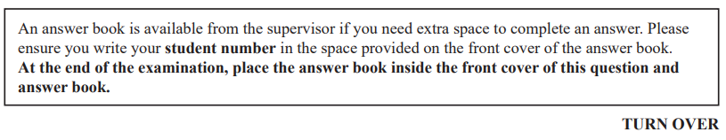

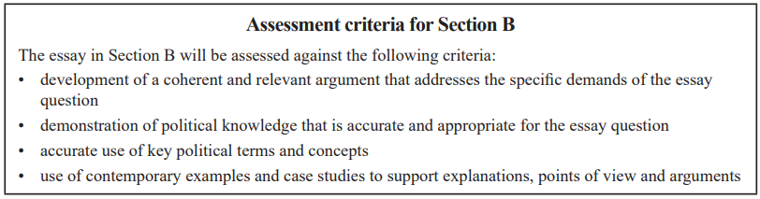

**END OF QUESTION AND ANSWER BOOK**

